Virtual Dom And real Dom



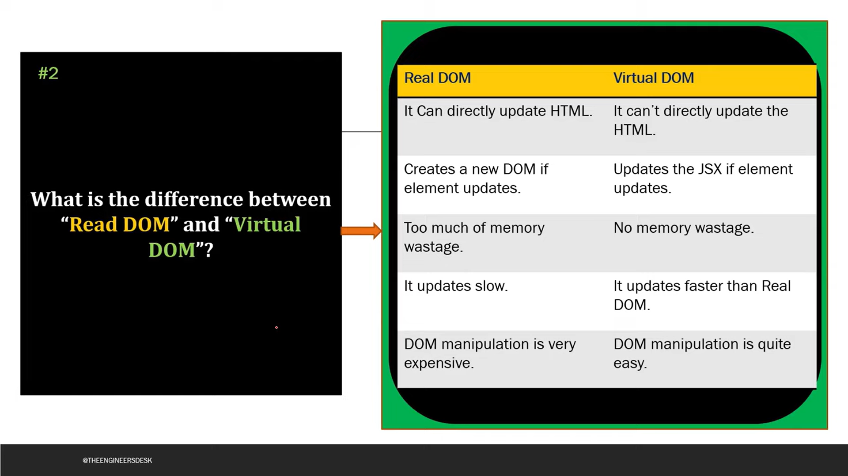





What is react



Features of react



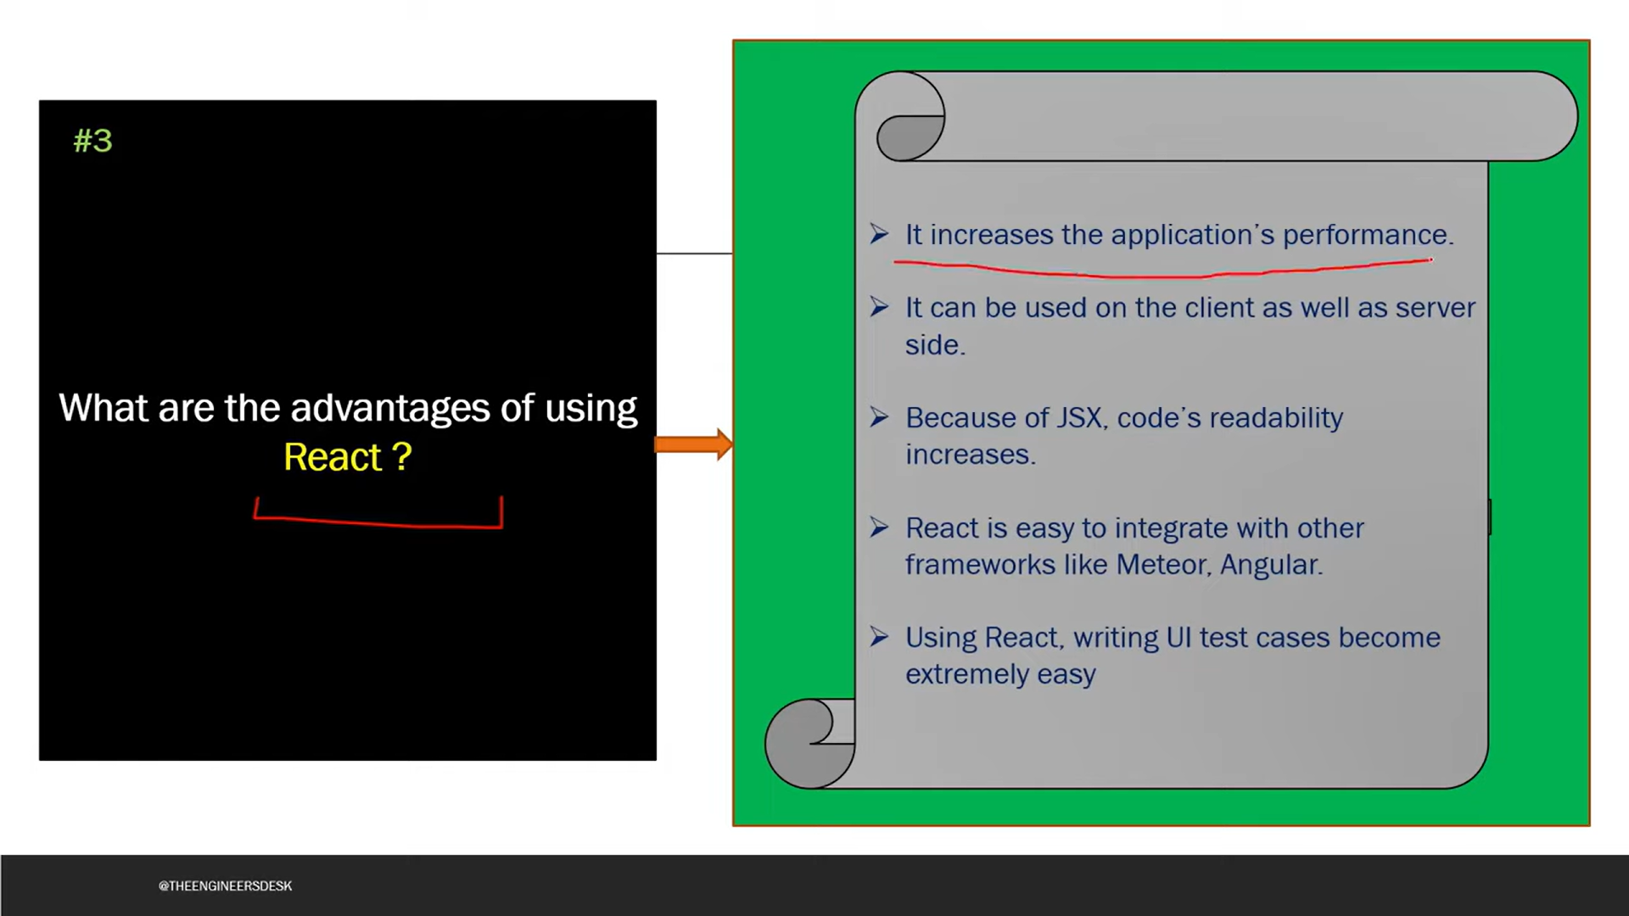

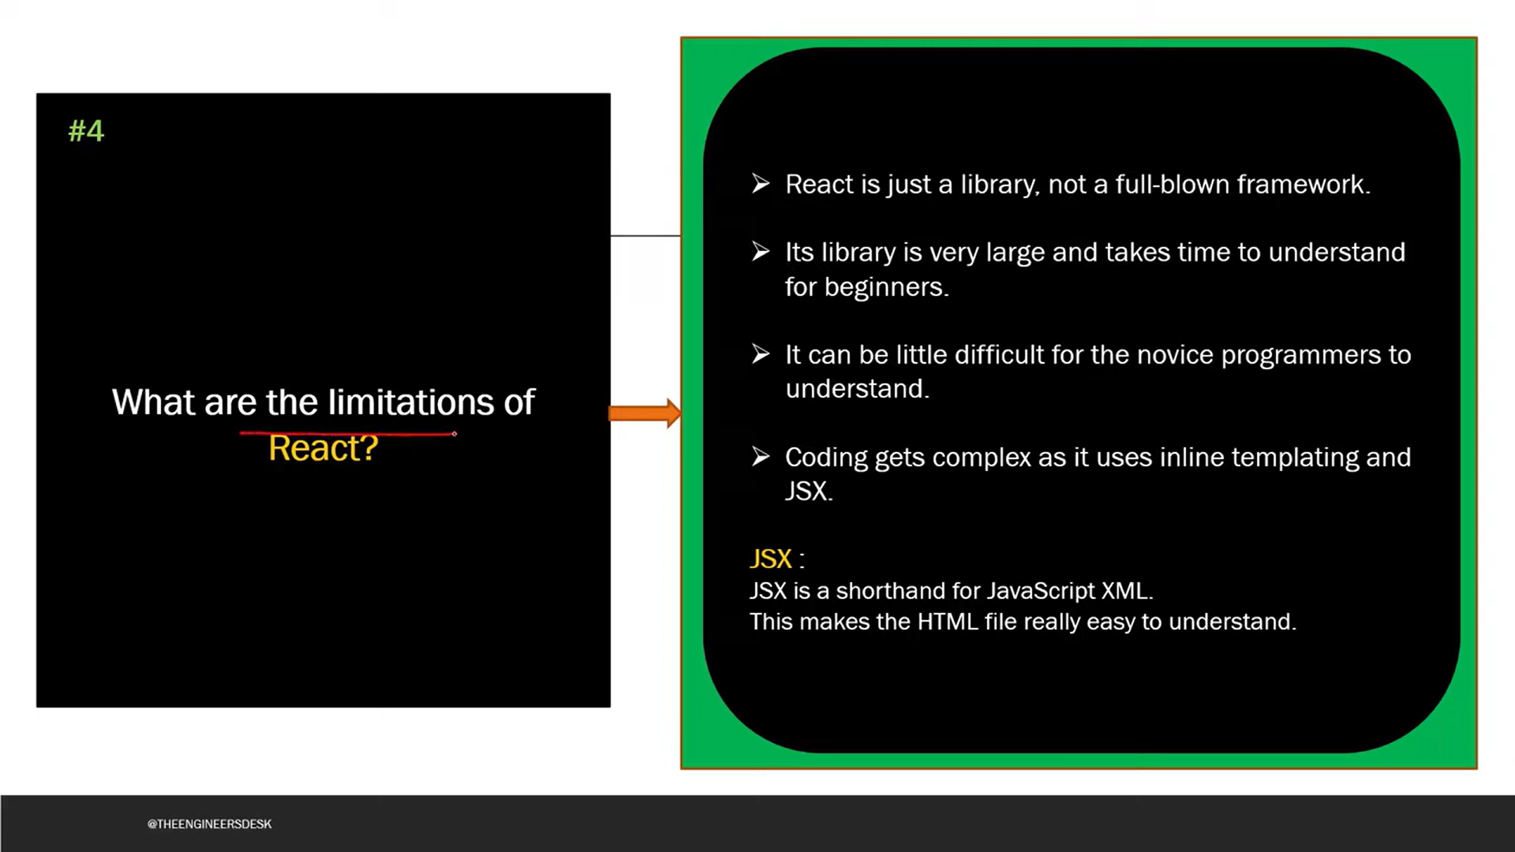

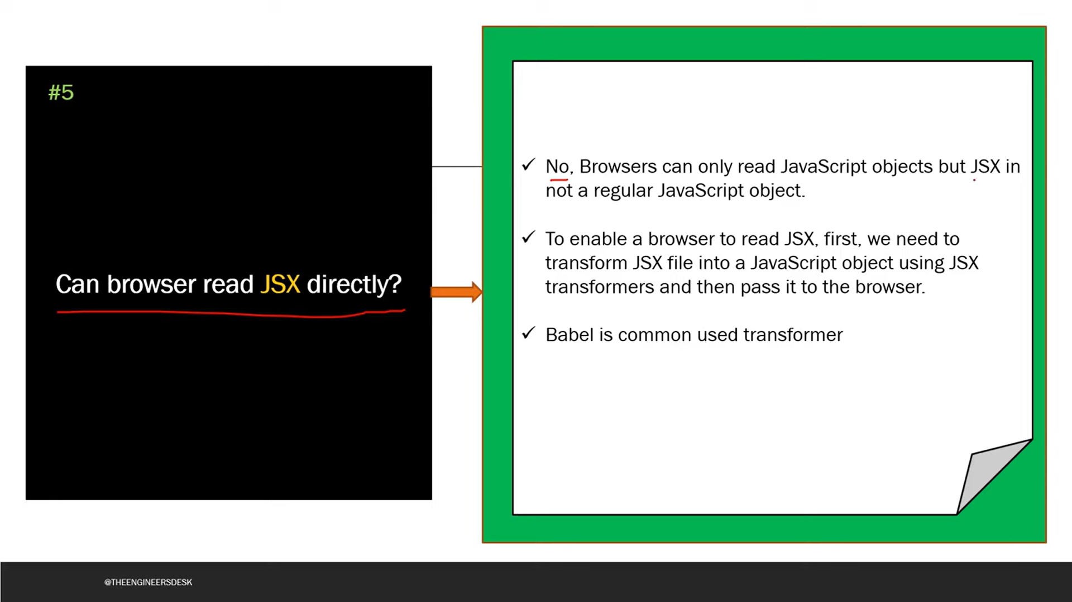

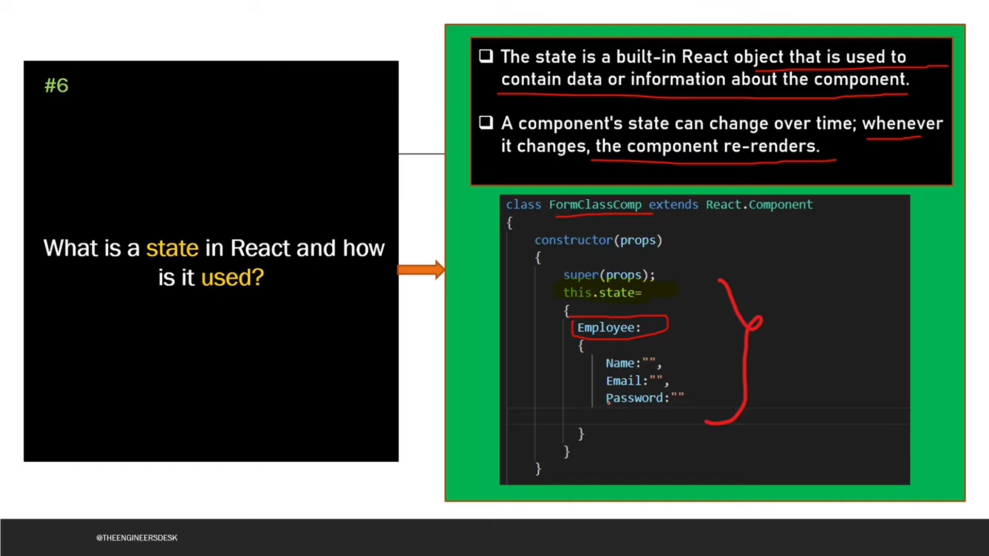

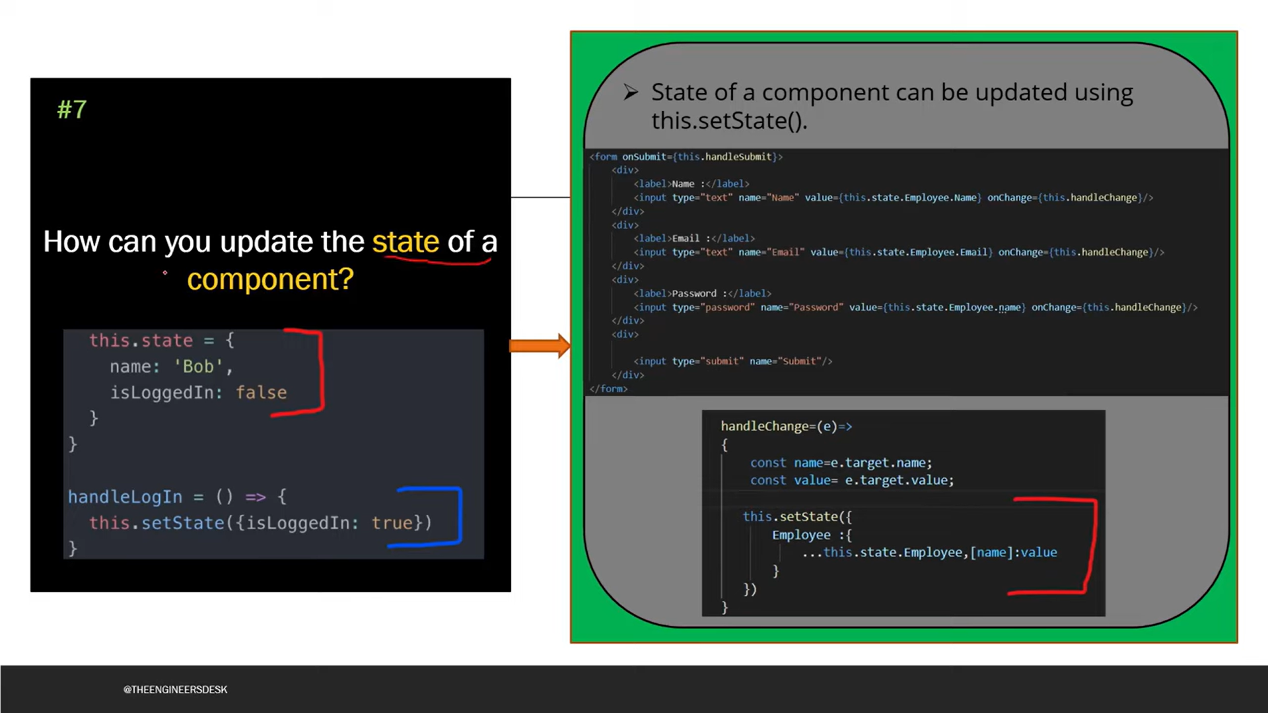

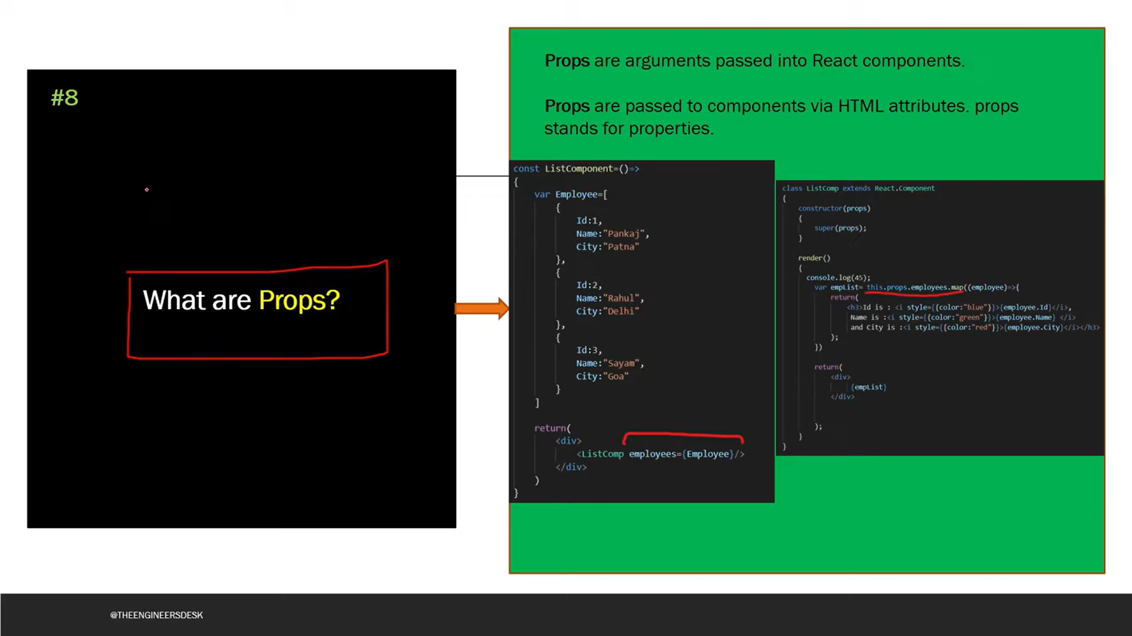

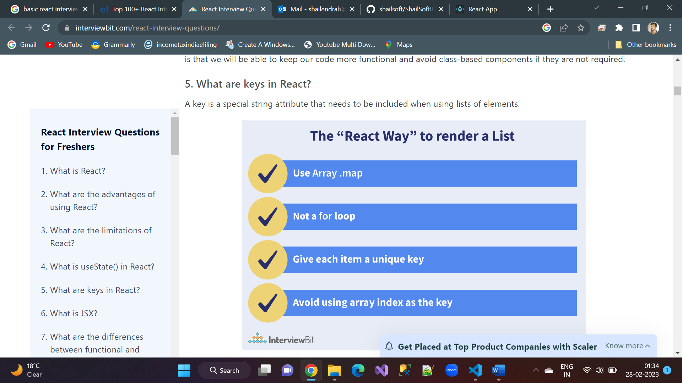

**What are the differences between functional and class components?**

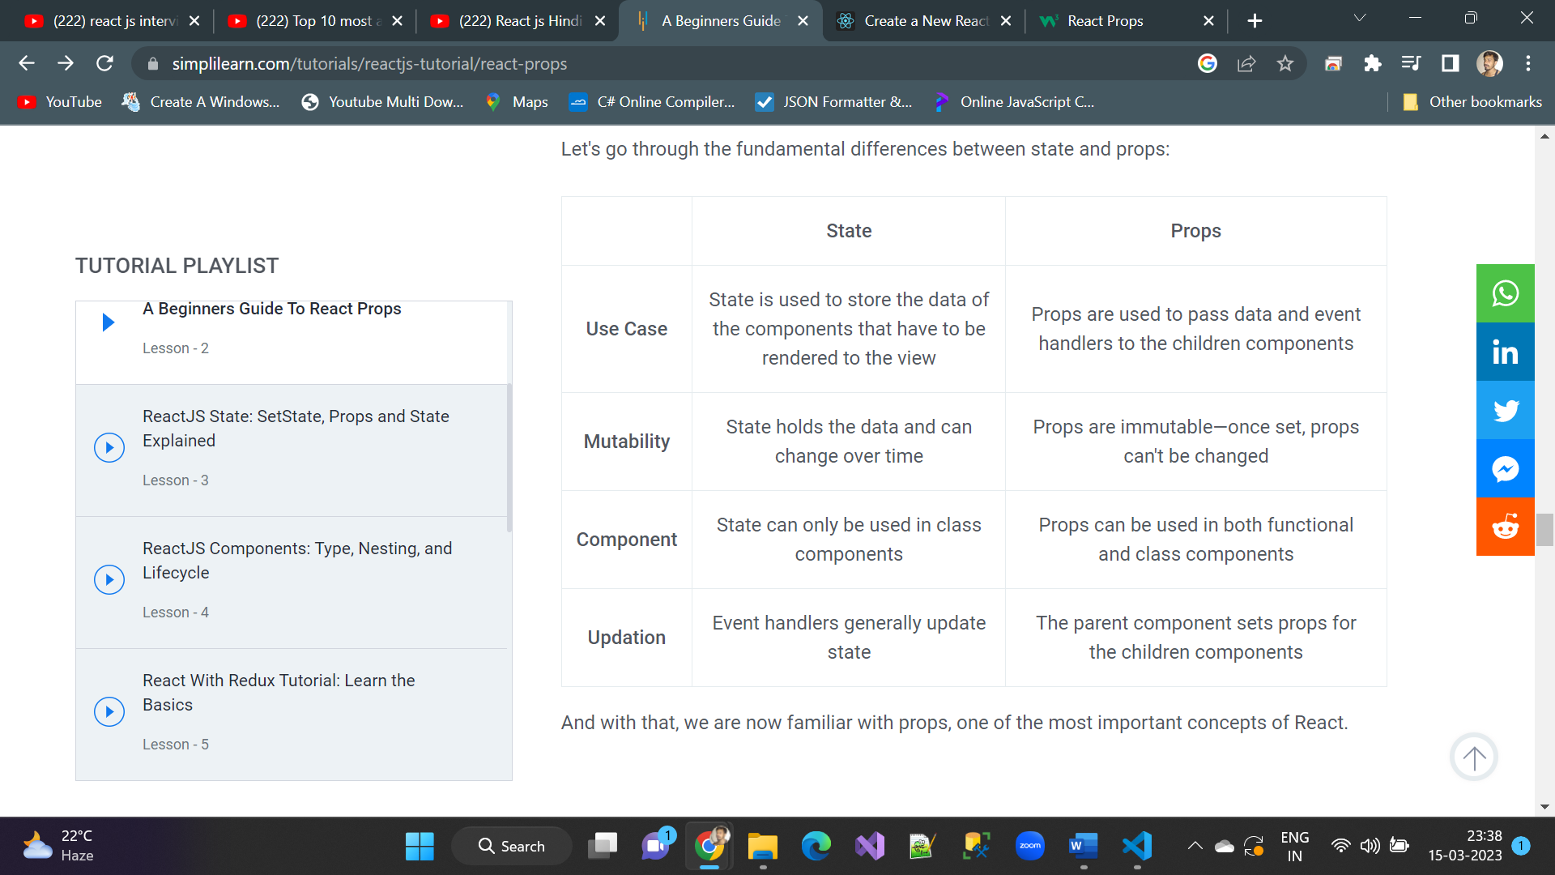

**Work flow**

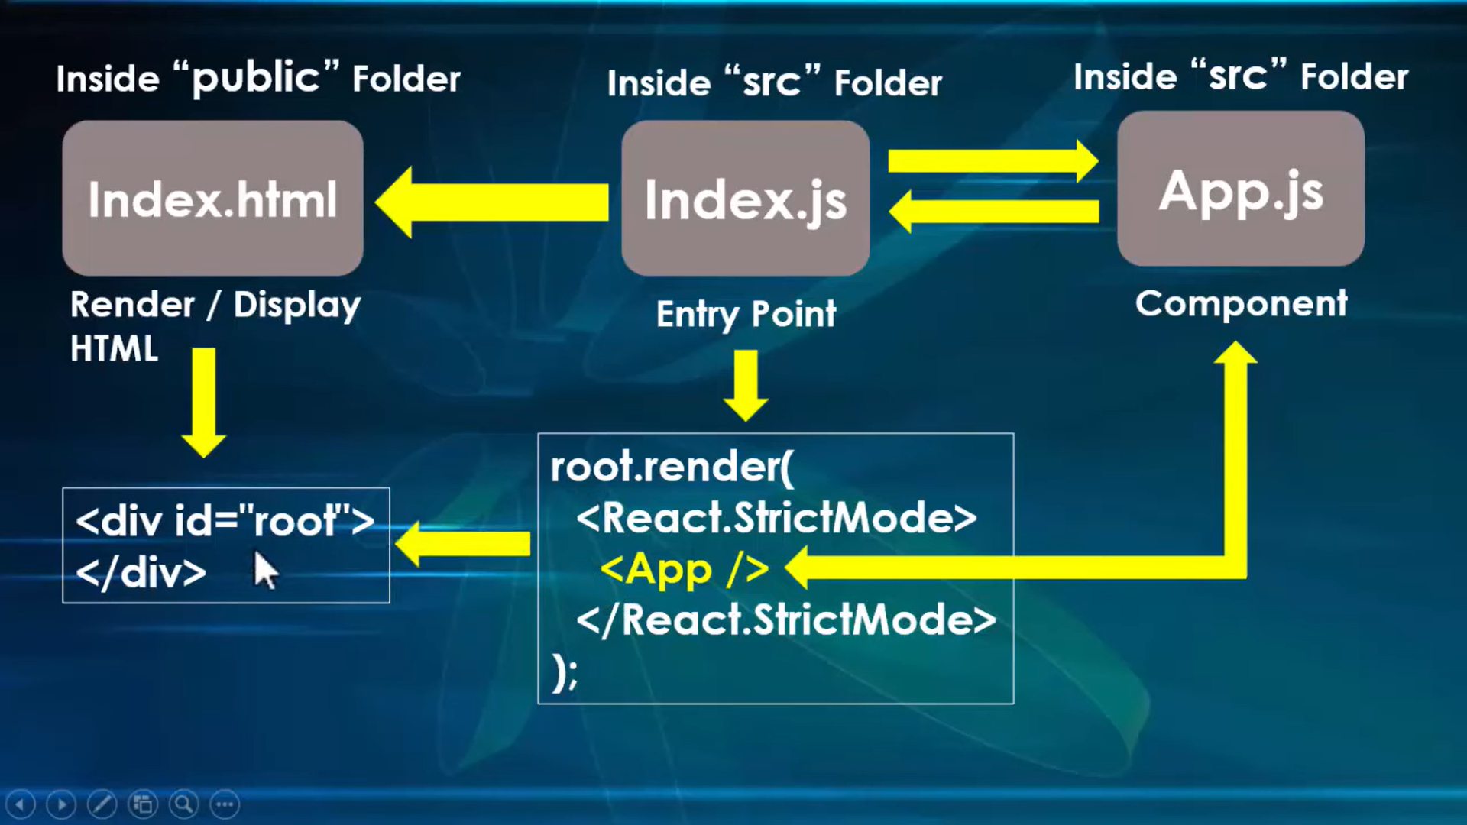

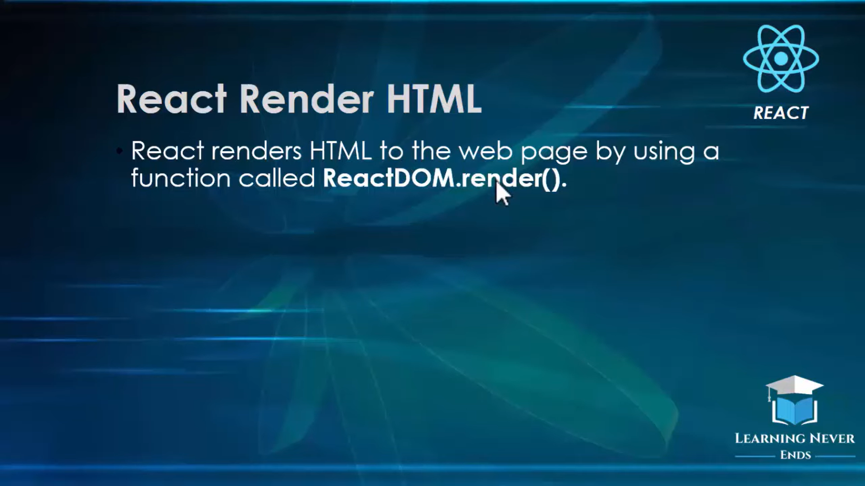

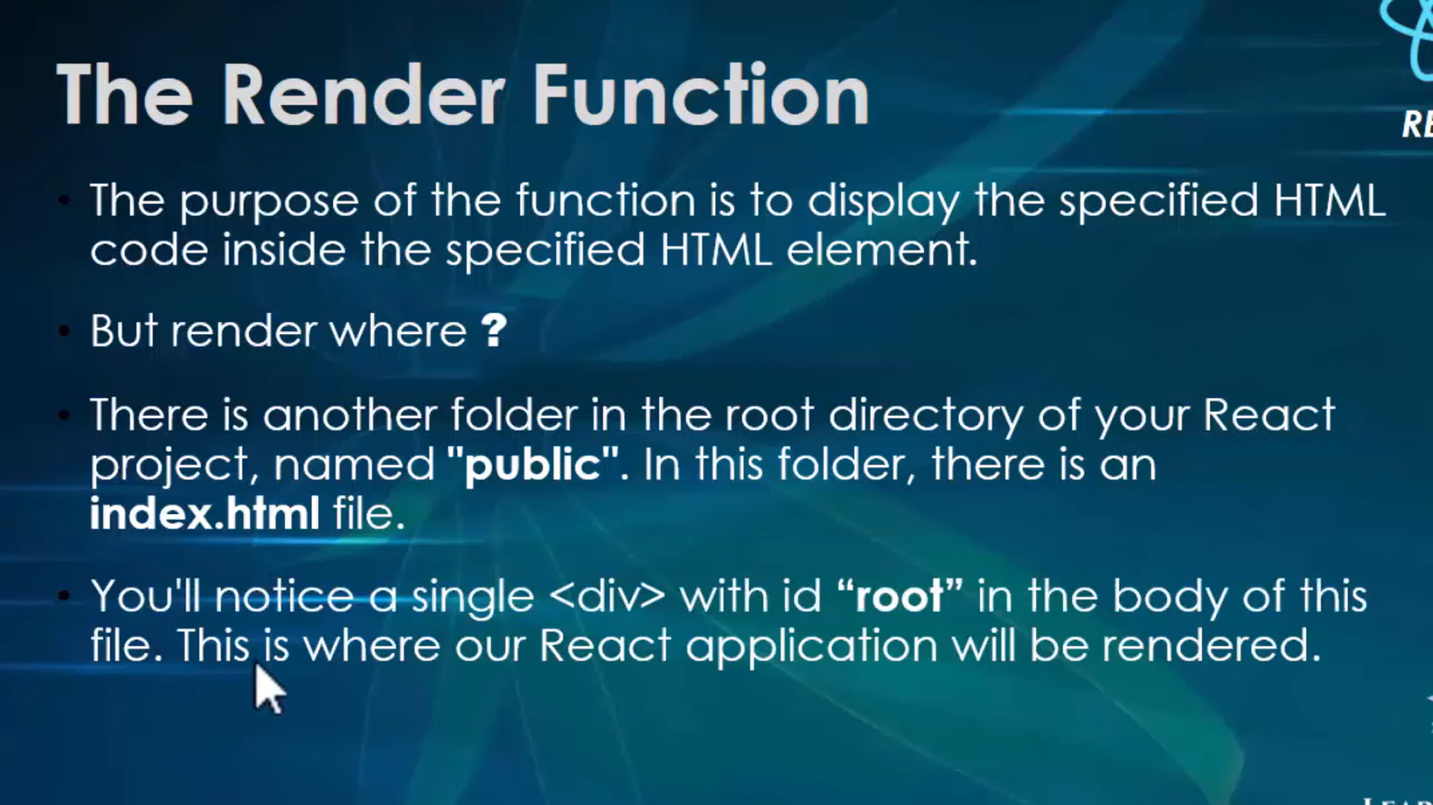

**What is JSX Why we use JSX in react**

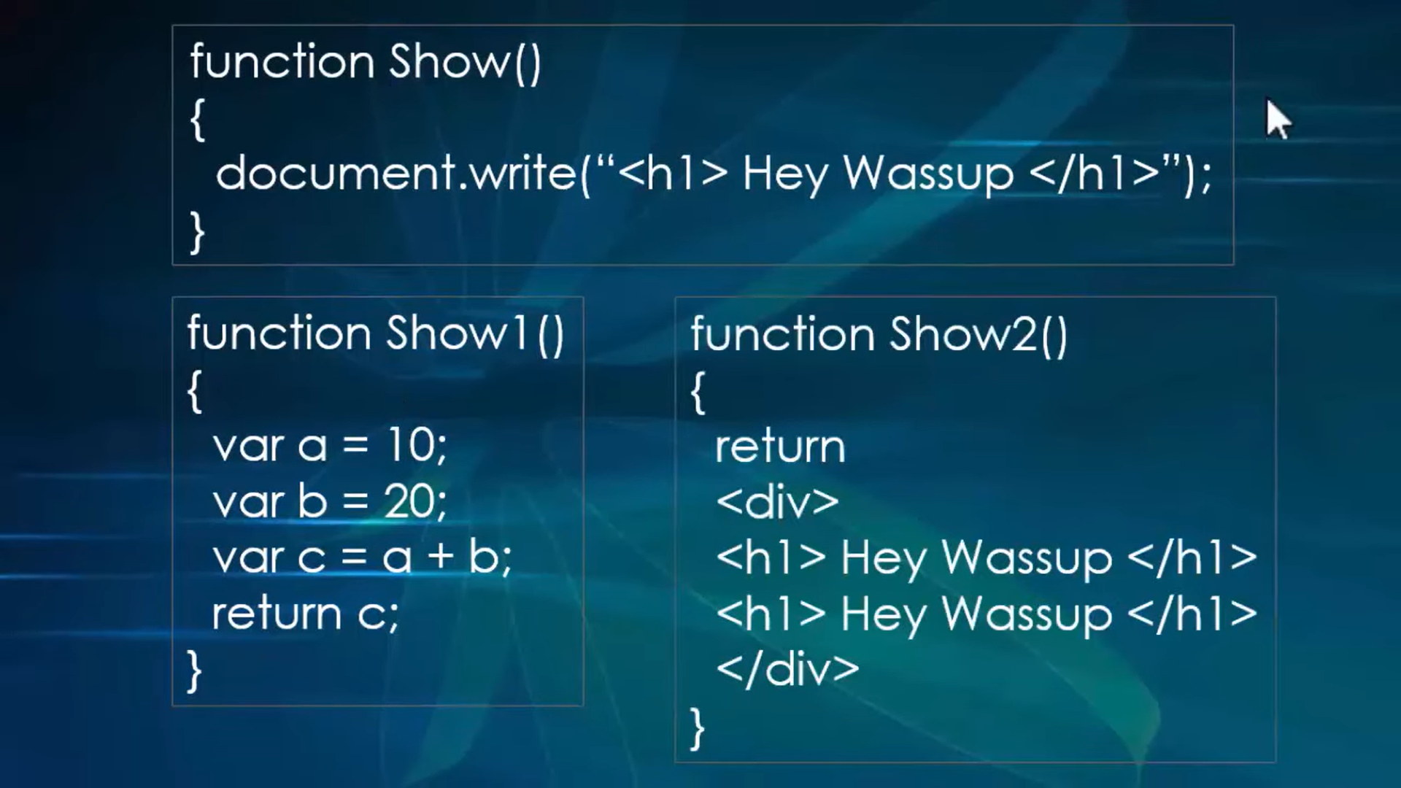



**Bable javascript online**

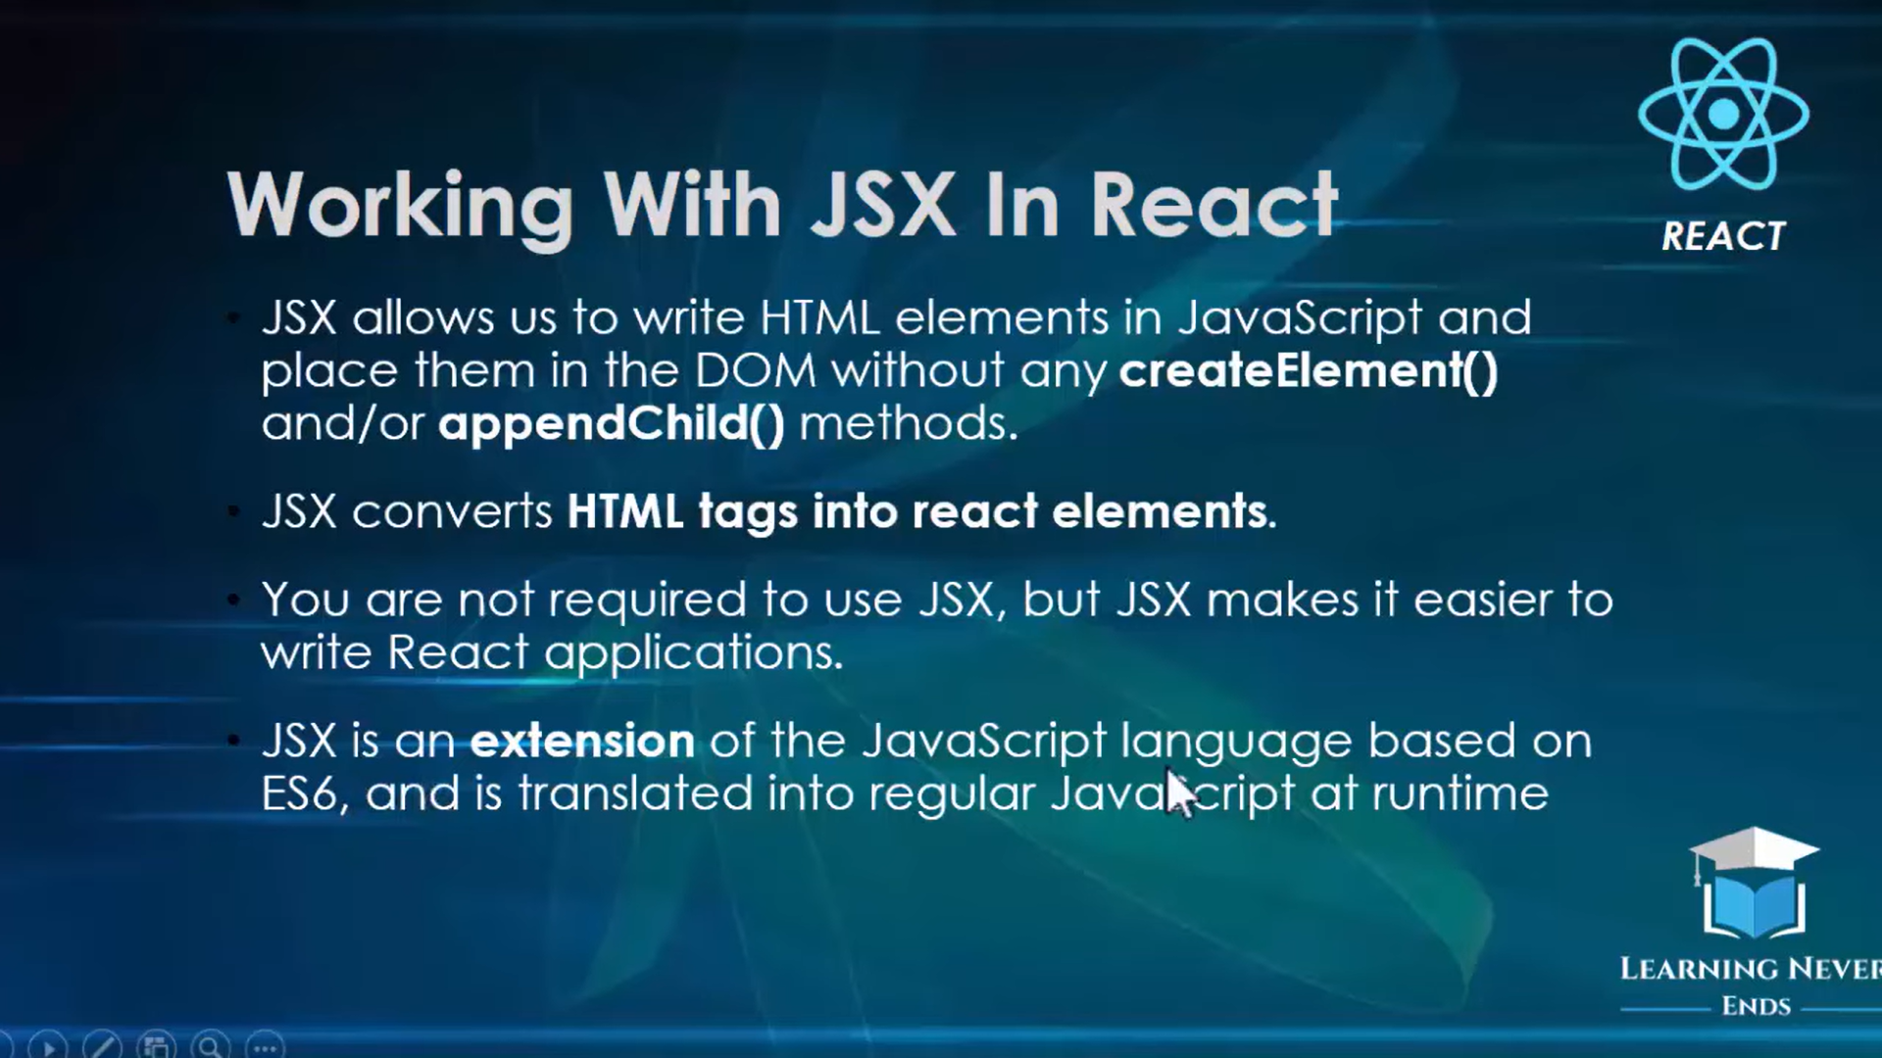

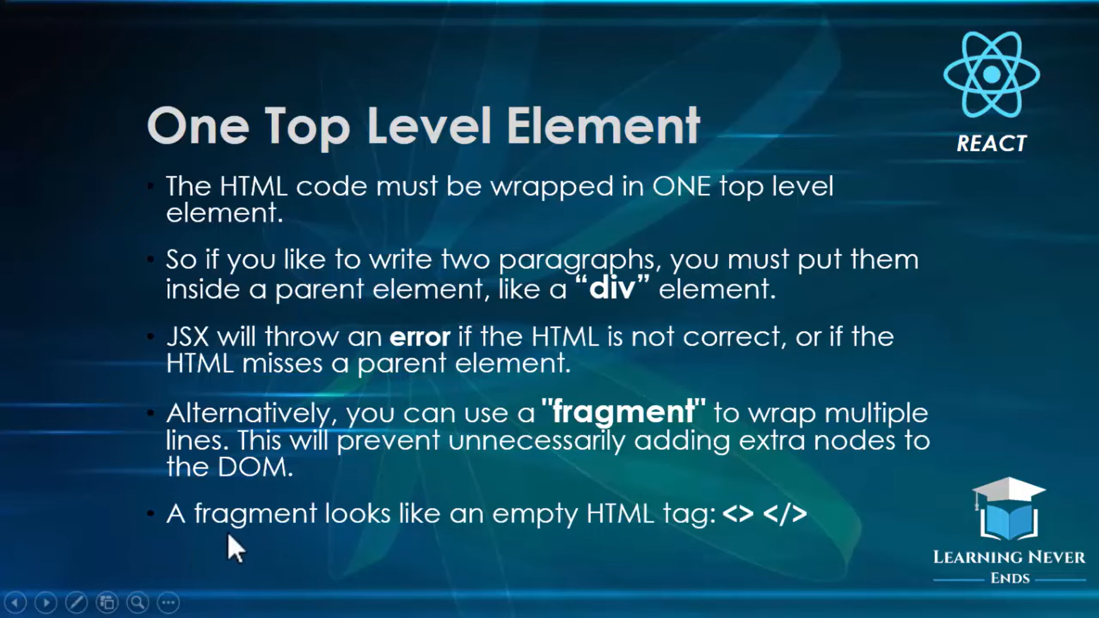

**React Component**

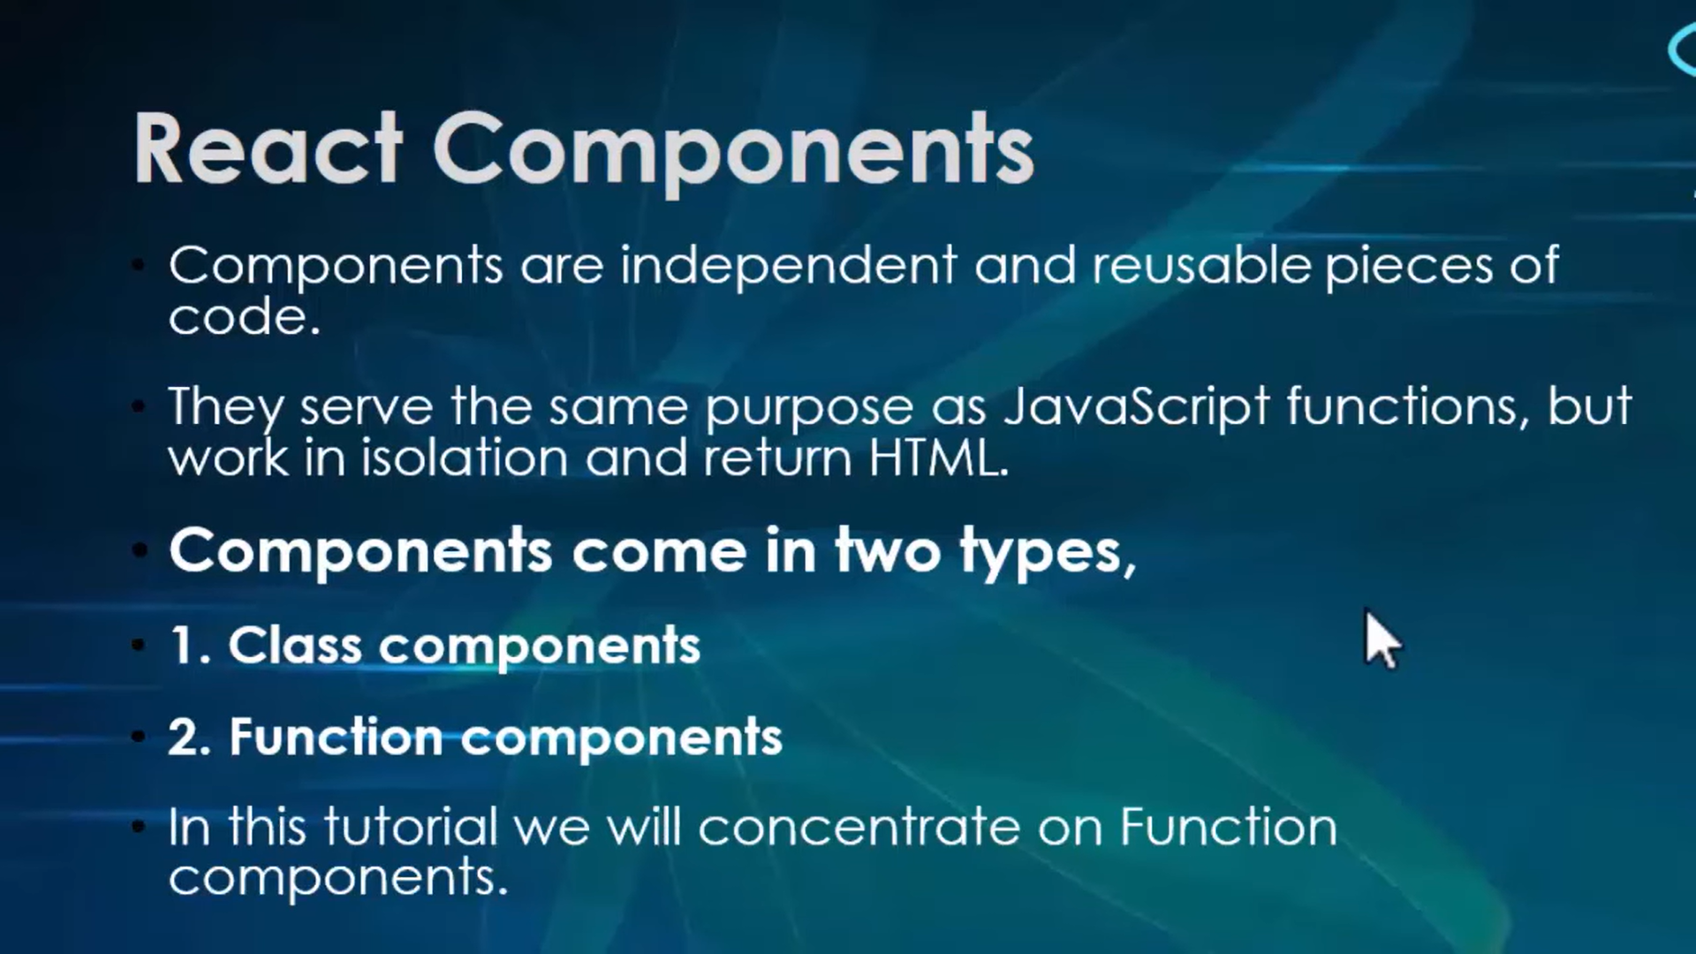



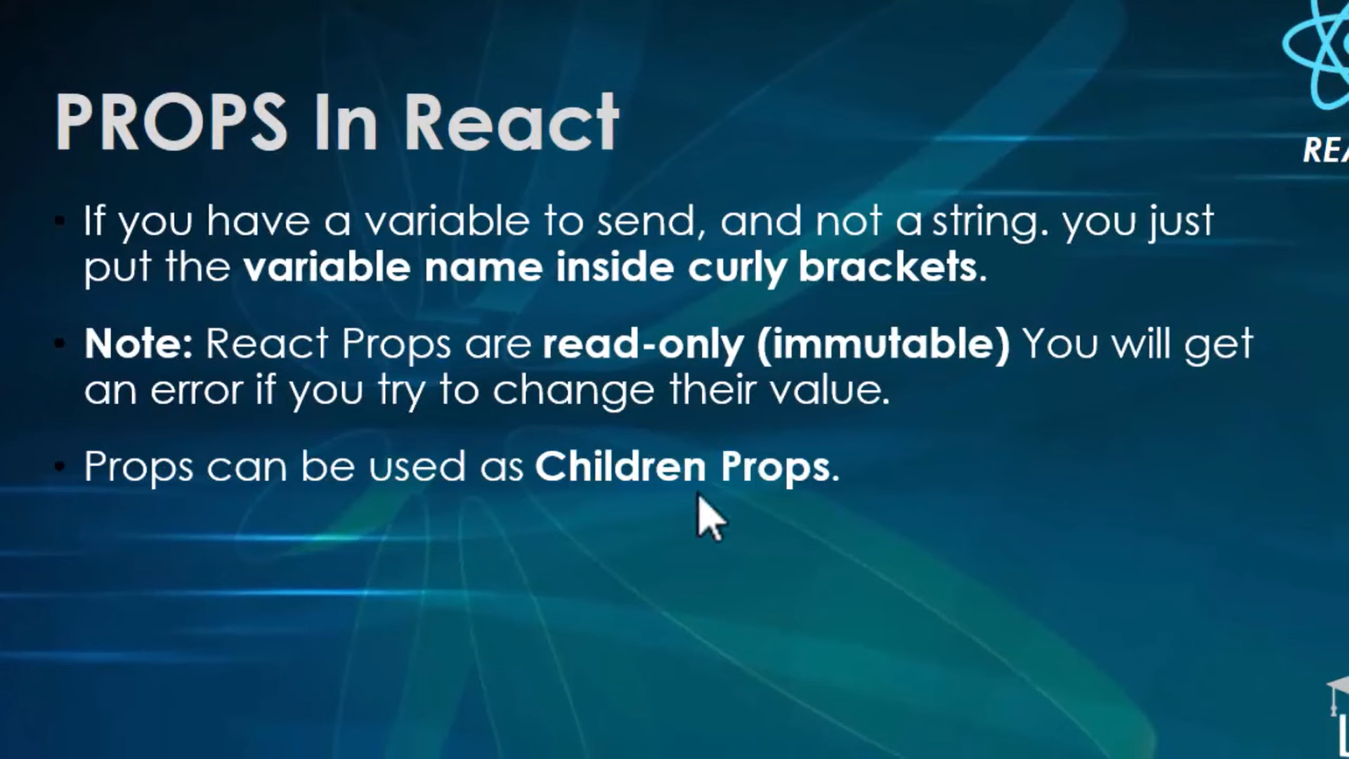

**Arrow function**

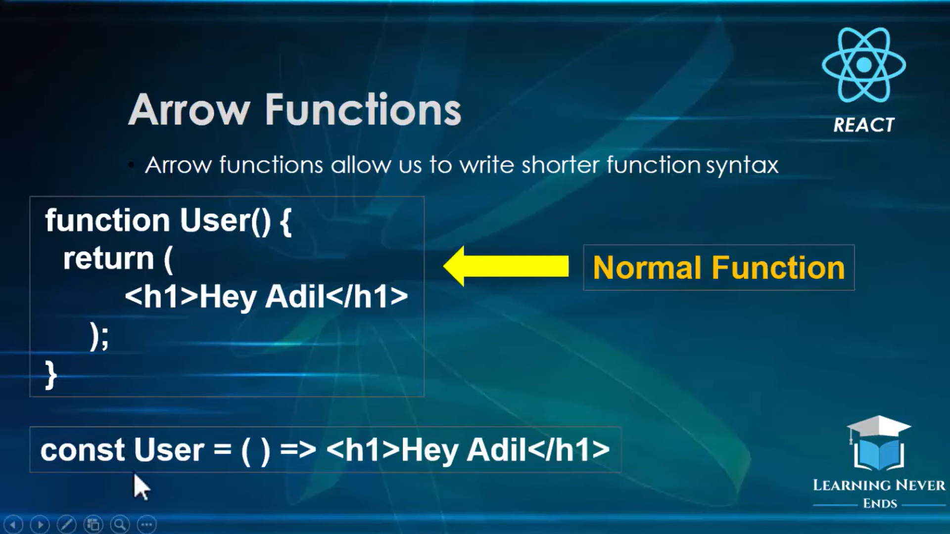

**Constructor in react**



**What is State in react js**

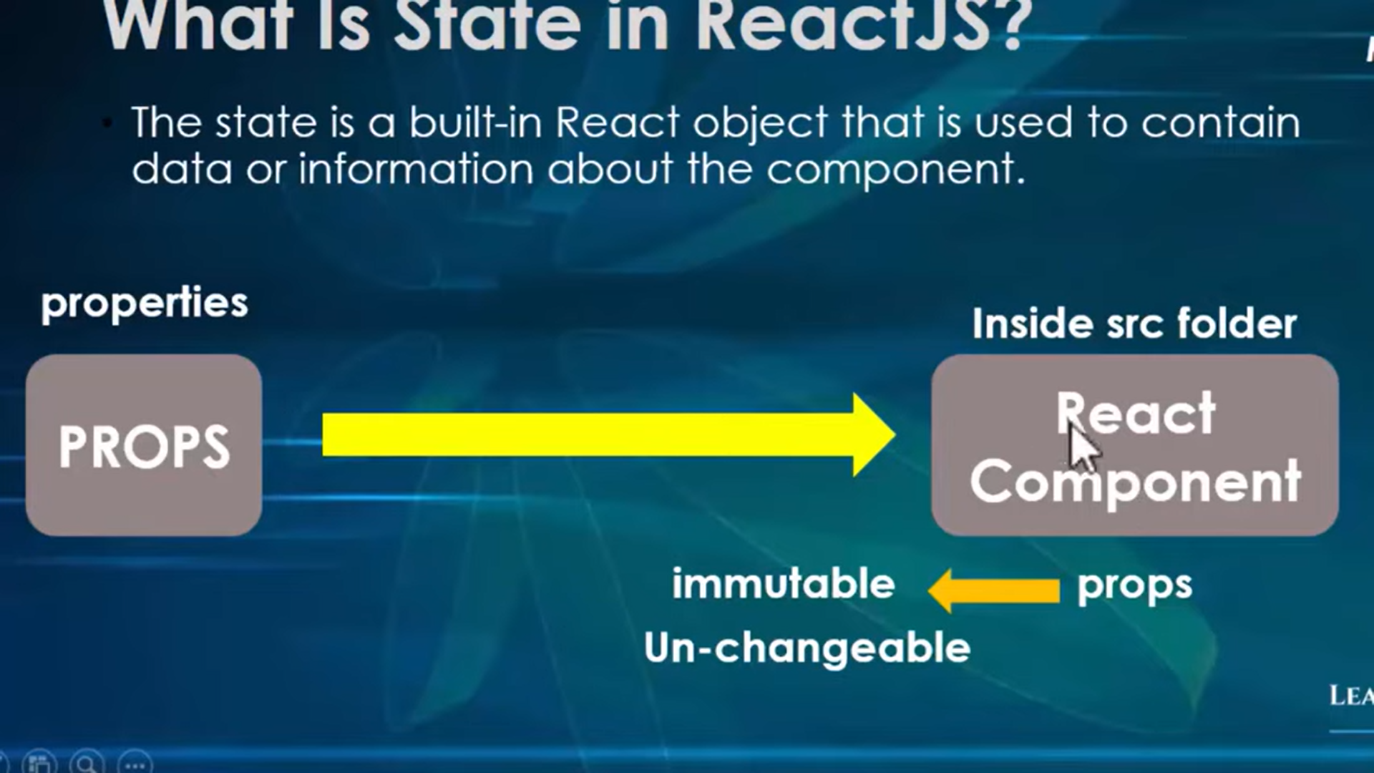

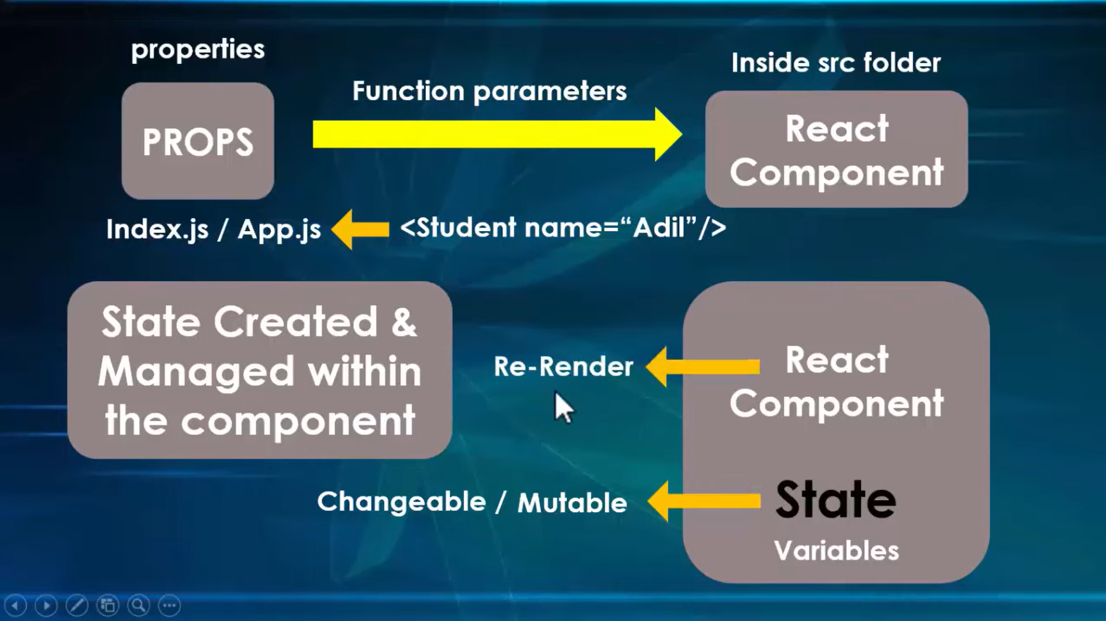



**Event Handler**

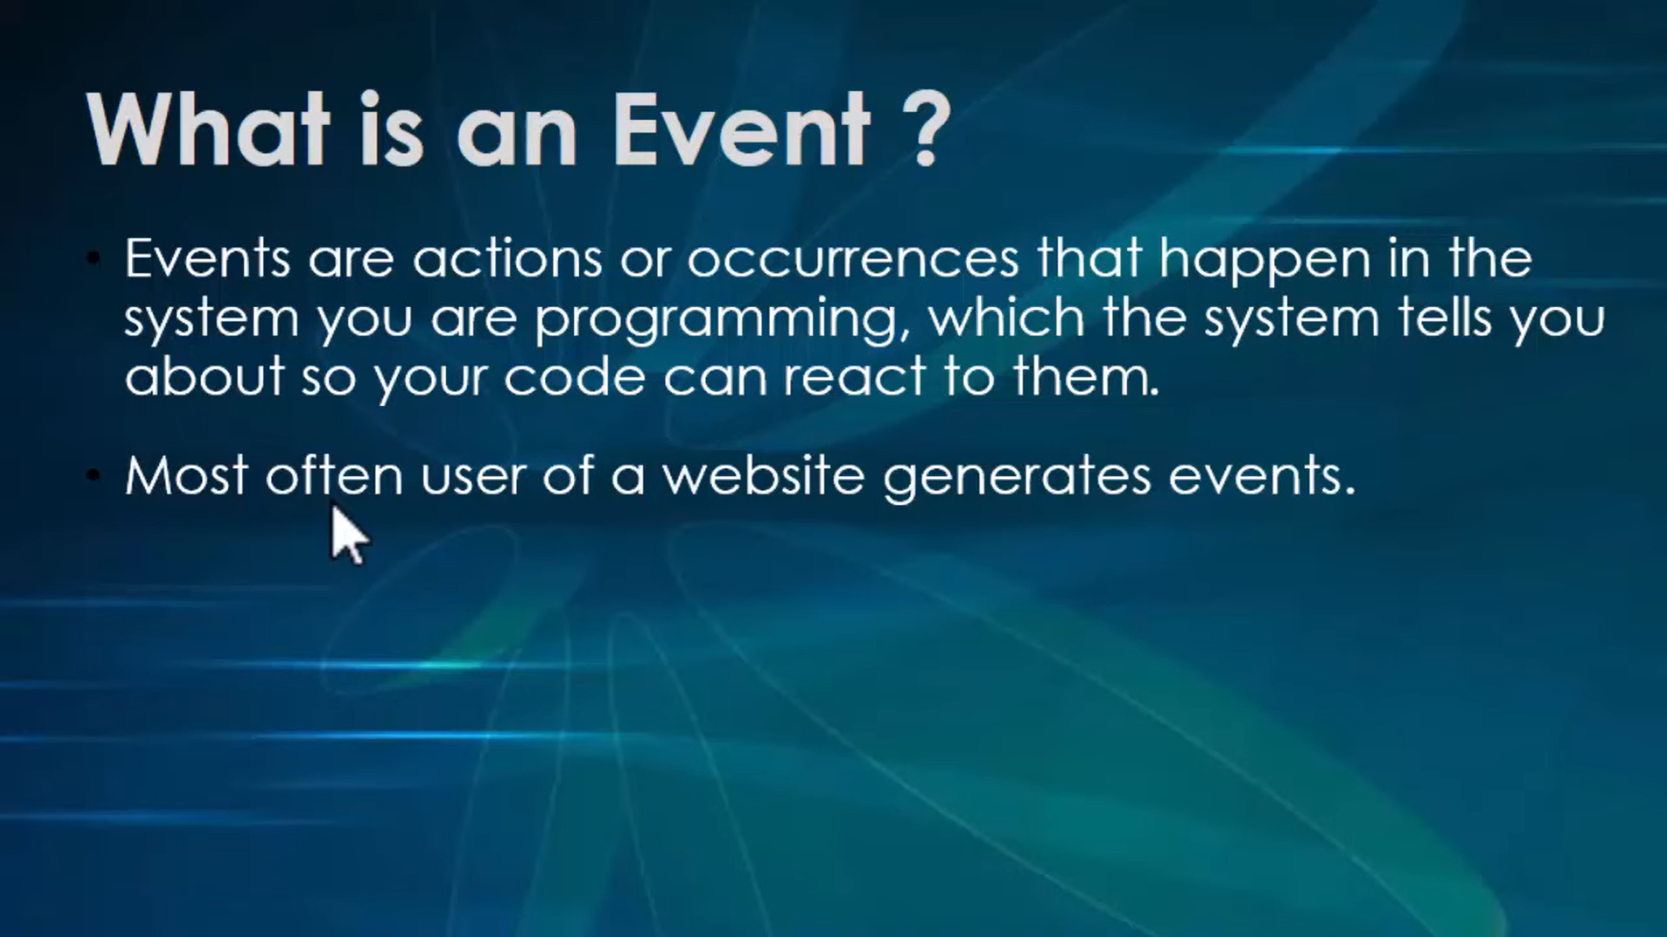

**Life cycle of component in react**

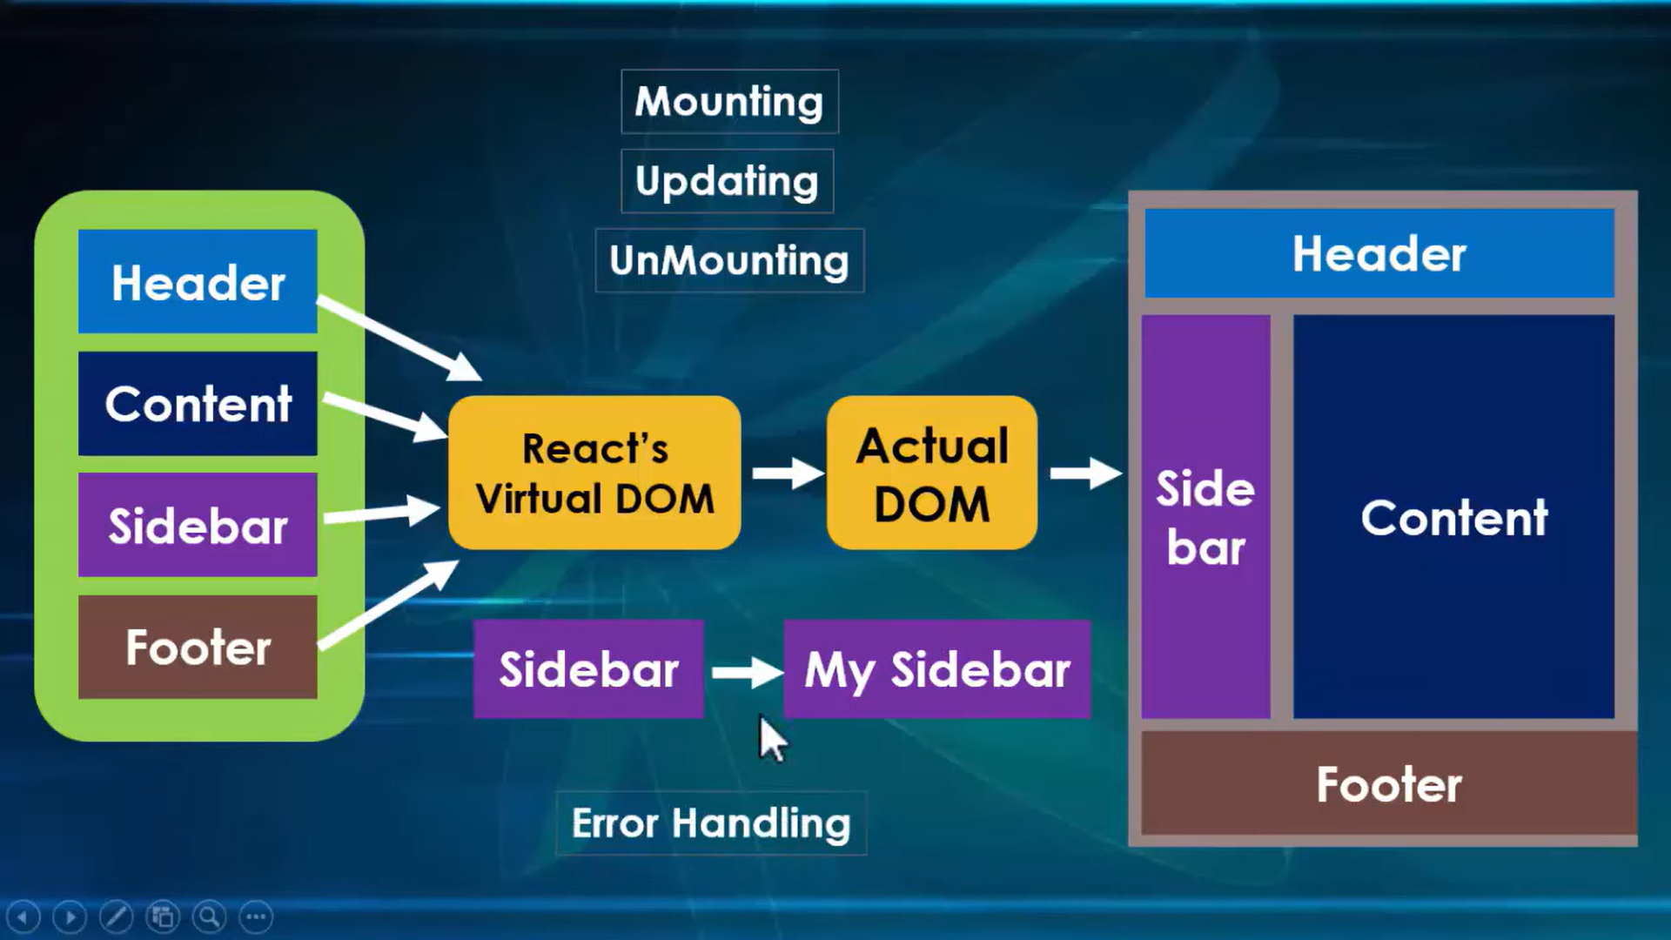





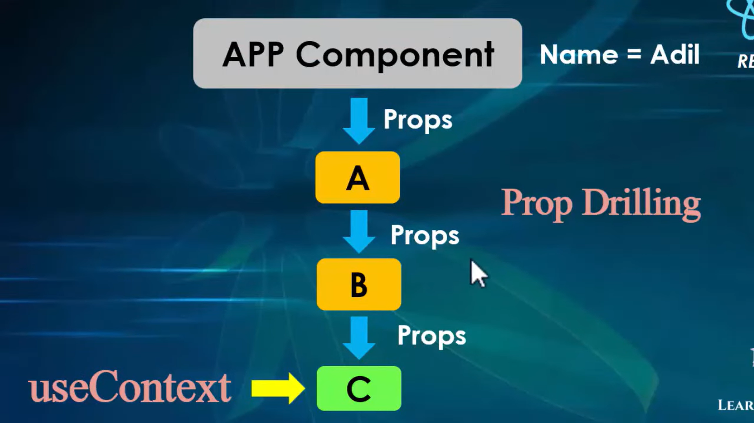

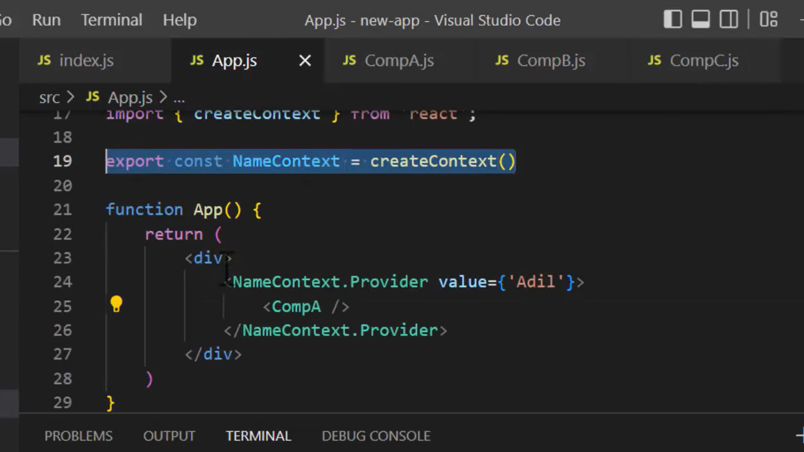

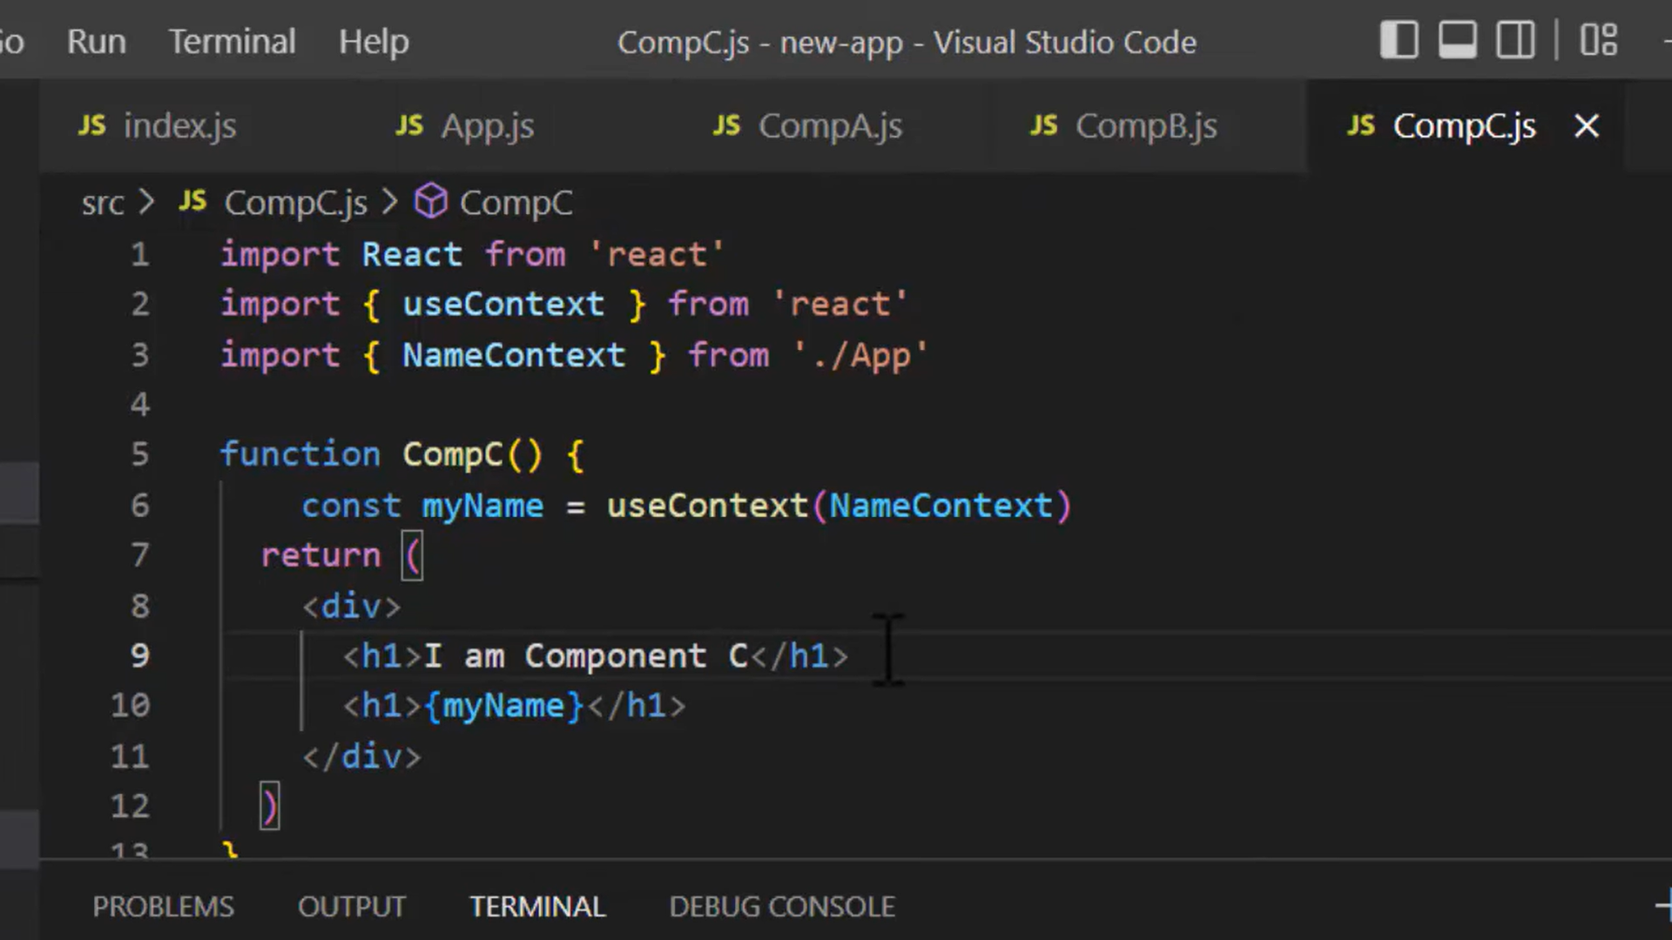

**What is the purpose of callback function as an argument of setState()?**

The callback function is invoked when setState finished and the component gets rendered. Since setState() is **asynchronous** the callback function is used for any post action.

**Note:** It is recommended to use lifecycle method rather than this callback function.

setState({ name: "John" }, () =>

console.log("The name has updated and component re-rendered")

);

**What is the use of refs?**

The ref is used to return a reference to the element. They should be avoided in most cases, however, they can be useful when you need a direct access to the DOM element or an instance of a component.

**How to create refs?**

There are two approaches

This is a recently added approach. *Refs* are created using React.createRef() method and attached to React elements via the ref attribute. In order to use *refs* throughout the component, just assign the *ref* to the instance property within constructor.

1. class MyComponent extends React.Component {
2. constructor(props) {
3. super(props);
4. this.myRef = React.createRef();
5. }
6. render() {
7. return <div ref={this.myRef} />;
8. }

}

You can also use ref callbacks approach regardless of React version. For example, the search bar component's input element is accessed as follows,

1. class SearchBar extends Component {
2. constructor(props) {
3. super(props);
4. this.txtSearch = null;
5. this.state = { term: "" };
6. this.setInputSearchRef = (e) => {
7. this.txtSearch = e;
8. };
9. }
10. onInputChange(event) {
11. this.setState({ term: this.txtSearch.value });
12. }
13. render() {
14. return (
15. <input
16. value={this.state.term}
17. onChange={this.onInputChange.bind(this)}
18. ref={this.setInputSearchRef}
19. />
20. );
21. }

}

You can also use *refs* in function components using **closures**. **Note**: You can also use inline ref callbacks even though it is not a recommended approach.

**PureComponent Pure component**

PureComponent is similar to [Component](https://react.dev/reference/react/Component) but it skips re-renders for same props and state. extend PureComponent instead of [Component:](https://react.dev/reference/react/Component)

[Skipping unnecessary re-renders for class components](https://react.dev/reference/react/PureComponent#skipping-unnecessary-re-renders-for-class-components)

If we are using function component then we can use useMemo

